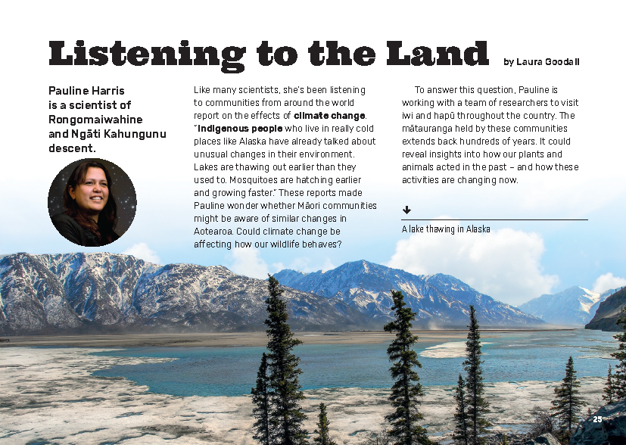
Connected
Level 3
2018

Listening to the Land
by Laura Goodall

Overview
This article describes how Pauline Harris, a scientist of Rongomaiwahine and Ngāti Kahungunu descent, is working with a team of researchers to collect and record mātauranga from iwi and hapū about plants and animals in Aotearoa. The team is using a computer program to record the mātauranga and connect it to particular times and places in history. They hope that this information will help us understand how climate change is affecting Aotearoa’s wildlife and ecosystems, knowledge that we can then use to plan for the change.
A Google Slides version of this article is available at www.connected.tki.org.nz
Curriculum contexts

SCIENCE: Living World: Ecology  Level 3 – Students will explain how living things are suited to their particular habitat and how they respond to environmental changes, both natural and human-induced. | Key science ideas  - Scientists collect data to contribute to solving environmental issues of concern.
SCIENCE: Nature of Science: Participating and contributing  Level 3 – Students will:  - use their growing science knowledge when considering issues of concern to them  - explore various aspects of an issue and make decisions about possible actions.  Science capabilities  This article provides opportunities to focus on the following science capabilities:  - Gather and interpret data  - Critique evidence  - Engage with science. | Key Nature of Science ideas  - Gathering data by making careful observations over long periods of time helps us identify patterns and relationships.  - Scientists will trust a theory more if there is a broad range of evidence developed from large sample sizes to support it.  - There may be more than one explanation for our observations.
ENGLISH: Reading  Level 3 – Ideas: Students will show a developing understanding of ideas within, across, and beyond texts. | Indicators:  - uses their personal experience and world and literacy knowledge confidently to make meaning from texts  - makes meaning of increasingly complex texts by identifying main and subsidiary ideas in them  - starts to make connections by thinking about underlying ideas in and between texts  - makes and supports inferences from texts with increasing independence.

ENGLISH: Writing  Level 3 – Students will organise texts, using a range of appropriate structures. | Indicators:  - organises and sequences ideas and information with increasing confidence.

The New Zealand Curriculum

Meeting the literacy challenges

The main literacy demands of this text do not lie in the concept of climate change, which most students will be familiar with. The challenge lies in interpreting and understanding what makes mātauranga Māori valuable to scientists and how scientific knowledge is acquired. Students will need a clear understanding of the purpose of the scientists’ work, as outlined on the first page, before engaging with the rest of the text.  The article incorporates quotations, side bars, and diagrams that offer additional information and help clarify ideas in the text. Students will need to take time to read the visual information.  The text includes some technical terms – their meaning is supported in the text and by a glossary. It also incorporates a substantial amount of te reo Māori, much of which is accompanied by translations in English. | The following strategies will support students to understand, respond to, and think critically about the information and ideas in the text. It may be appropriate to use all or only one or two of these strategies, depending on your students’ literacy knowledge and skills. You are encouraged to reword the suggested questions that will best suit your learners’ strengths and needs.  You may wish to use shared or guided reading, or a mixture of both, depending on the reading expertise of your students and the background knowledge they bring to the text.  After reading the text, support students to explore the activities outlined in the following pages.

INSTRUCTIONAL STRATEGIES

Finding the main ideas  TELL the students that they will be reading an article about how scientists are collecting mātauranga Māori to find out how climate change is affecting our natural environment. Write “climate change” on your whiteboard and have the students brainstorm what they know about it. Repeat this for “mātauranga Māori”, then ask the students what possible connection the two might have. RECORD their ideas. How do you suppose mātauranga Māori might help scientists learn more about climate change?  DISCUSS how scientists go about an investigation, drawing out the ideas that they:  - set a purpose and form a question for inquiry  - review relevant background information  - collect data, making sure that it is valid  - record and organise their data  - analyse their data  - use their data to draw conclusions and decide on next steps.  Record these ideas as headings and have the students SCAN the title, headings, and images to get an idea of where they will read about each of them.  What clues do you get from the subheadings?  What do the diagrams and pictures suggest to you about what is covered in each section?  Introduce the students to the note-taking approach called Cornell Notes. The template below suggests terms you might include in the cue column. The students could take notes independently or in pairs during their first reading, then move into small groups to share and discuss their notes and write their summary paragraphs. If they have completed their notes digitally, they might also like to combine their notes and order them in a way that feels logical. (Currently, they are ordered by when they appear in the text. Do they form natural groups? Do relationships emerge?) | Cue column Note-taking area  mātauranga Māori  oral tradition  phenology  plant and animal cycles  maramataka  changes in the environment  capture information  observing the past  confirm or rule out  compare the stories and look for similarities  layers of information  evidence  ecosystems  adapt  Summary  Have the students identify how the investigators supplement the mātauranga with other sources. EXPLAIN what makes this scientific behaviour, pointing out that while these scientists value and trust the observations and knowledge found in mātauranga Māori, they will always look for more information to make the evidence even stronger.

Meeting the literacy challenges

Using design features for deeper understanding  MODEL the use of open-ended questions to draw information from the photo on page 25.  What is this picture showing?  Why has it been used?  What more can you find?  Working in the same small groups as for the note-taking activity, have the students repeat this activity for each of the images in this article. They could take turns to be the person asking the probing questions, the person recording the answers, and the person or people seeking the information. They could use the following template to record this information.  What is this picture showing? The clues that make us say that Other things we see when we look again  Photograph, page 25  Photograph, page 26  Diagram, page 27  Chart, pages 28–29  Picture, page 30  Diagram, page 31  Photographs, page 32 | DISCUSS how the process of asking and answering questions about each image affected the kind of information they were able to take from them.  - What did you notice when you looked again?  - How did the questions help?  - How did other people’s comments help?  Dealing with unfamiliar vocabulary  If the students have difficulty with the technical terms or te reo Māori, prompt them to recall their strategies for finding the meanings of unknown words, including using the glossary, finding explanations in the text, or using a dictionary, such as the online Māori dictionary.

TEACHER RESOURCES

Want to know more about instructional strategies? Go to:  - http://literacyonline.tki.org.nz/Literacy-Online/Planning-for-my-students-needs/Effective-literacy-practice-years-5-8  - “Engaging Learners with Texts” (Chapter 5) from Effective Literacy Practice in Years 5 to 8 (Ministry of Education, 2006).  Want to know more about what literacy skills and knowledge your students need? Go to:  - http://nzcurriculum.tki.org.nz/Assessment/Reading-and-writing-standards  - http://www.literacyprogressions.tki.org.nz/ | We have retained the links to the National Standards while a new assessment and reporting system is being developed. For more information on assessing and reporting in the post-National Standards era, see:  - http://assessment.tki.org.nz/Assessment-and-reporting-guide

Reading standard: by the end of year 6
The Literacy Learning Progressions
Effective Literacy Practice: years 5–8

Illustrating the key ideas

TEACHER SUPPORT
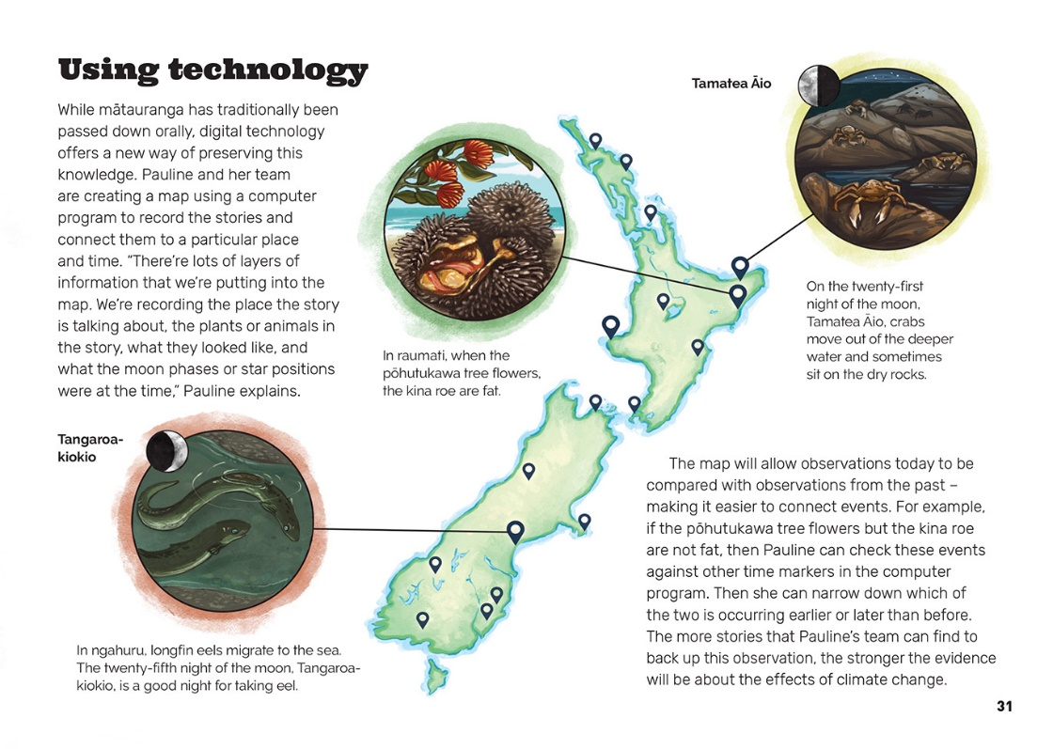
Gathering data by making careful observations over long periods of time helps us to identify patterns and relationships.
Scientists will trust a theory more if there is a broad range of evidence developed from large sample sizes to support it.
There may be more than one explanation for our observations.

Learning activities – Exploring the science
The following activities and suggestions are designed as a guide for supporting students to explore and extend student content knowledge across the learning areas. Adapt these activities to support your students’ learning needs.

Activity 1 – Local stories of change

Planning the investigation
Have the students record information about changes to a local resource that is important to their community (for example, the impact of erosion; a decline in kaimoana in a local waterway or bird life in the bush; or pollution in a local waterway). Ideally, they will engage with local hapū and iwi to learn from mātauranga Māori, but students should also be aware of other sources of local knowledge, such as that held by members of their whānau, elderly neighbours, people who have lived in the area for a long time, or local historical or environmental groups. Encourage them to think locally but also globally.
What changes have been observed in our local environment?
Have any of us noticed changes? Have we heard older members of our whānau mention changes? What are the changes that they talk about? Do you think they are positive or negative changes? Why?
Which change should we focus on?
Who is most likely to have information about this change?
What do you think is causing the change? What is our hypothesis?
What information can we use to confirm or rule out whether our hypothesis is correct?
We think our hypothesis is correct – where else can we find evidence to strengthen our case?
Is this just a local issue or is it connected to something that is happening around the country or around the world?

Recording and presenting the information
At the same time as the students are thinking about their research methodology, they should also be thinking about how they can use digital technology to record and present their information.
Who should hear this information and why?
How will we record the information? How will we present it?
How could we use digital technologies to make the information available to a wider group of people?
Can we include photographs or diagrams to show the change and explain the processes involved?
It’s important that the students prepare respectfully for any interviews they will undertake, including conducting background research, shaping a central hypothesis, preparing interview questions, and making arrangements to ensure their subjects feel relaxed and comfortable. They should also let their interviewees know if they plan to share the information with a wider audience.
Provide the students with the opportunity to get familiar with the technology they will use to record and edit their findings. (See some examples of suitable apps in the resource links.) Keep this reasonably simple so that issues with technology don’t overwhelm engagement with the topic. Make sure you identify and take courteous advantage of your digital experts – students who can help their peers wrangle technical issues. When the students have collected and edited their stories, they should also think about how they will make them available for others to listen to.

Taking action
Having identified a change in the environment, prompt the students to think about what they can do about it. They could petition for an end to plastic in school lunches or collect rubbish from beside a stream, taking photographs and measurements and publishing the results in the school or community newsletter. Leave the students with the message that negative change does not have to be irreversible and that they don’t need to wait to take action – there are things they can do and people and organisations they can support now.

Activity 2 – New technologies – taking a stand
The project Pauline and her colleagues are involved in is an example of “cultural mapping”. Explore examples of cultural mapping and use this to prompt discussion about how Māori are using this method to ensure data can be stored, retrieved, shared, and made secure for future generations. (Currently, the best example is probably that of Ngai Tahu.)
Show the students examples of how satellite images are being used to find out the impact humans are having on the planet. Examples are provided in the list of resources below, but the students could also find more of their own.
Present the following two statements:
- Our rush to adopt new technologies is ruining our environment and threatening our existence.
- New technologies give us great power to understand our world and adapt to change.
Challenge the students to decide where they stand on these statements. They could stand on a continuum and explain their position to the people next to them. Then they could write a personal statement explaining the impact of new technologies and whether it’s time to slow down. Note that this is a conversation that could continue as the class engages with other learning opportunities around technological change and the environment.

Extension
Continue the discussion about the tension between the advantages and disadvantages of new technologies. Explore other Connected items that look at how mātauranga Māori and Western science can interact to create new knowledge and guide further action. Groups of students could investigate different examples (such as those discussed in recent Connected articles) and collate what they discover on a template, such as the one below. Alternatively, focus on different types of new technologies and the ways they impact on society. After the groups have shared what they have learnt, they could continue the discussion about new technologies, their impact, and how we should respond.

Learning activities – Exploring the science

Focus of the investigation  Context in which the investigation is taking place  The people who are involved  The central question for inquiry  The hypothesis  The role of mātauranga Māori in this investigation The role of Western science in this investigation  The new knowledge that was (or is being) created  Possible applications for this knowledge  Reflection: What we think now about the advantages and disadvantages of new technologies and scientific discoveries | Activity 3 – Making and recording observations in our local environment  Discuss how people observe and record changes in the environment (for example, by keeping track of rainfall or temperature). Have the students explore practical ways they can gather information, look at patterns and trends, and make inferences based on their observations (for example, making and keeping rain level gauges). Select one or more examples and use this as an opportunity to collect, record, organise, and analyse data.  Have the students investigate plants that are indigenous to the local area and observe the ways that they respond to natural triggers, such as rainfall, day length, and warmth. In what conditions are these plants most commonly found? Do they flower and produce fruit? If so, when? What features help them survive?  What does this suggest about plants in our local area and what they need to be healthy?  What does this suggest about how changes in the environment might affect the health of our indigenous plants?  What are some features of our local environment that should be monitored? How should they be monitored? Whose responsibility is it?  Are some features already being monitored? Why? Which features? Who by? And how? Do they give us insights about change over time?  If there are changes, should we do anything? What? Why?  Extension  Provide the students with the opportunity to turn concern into social and/or scientific action.

Learning activities – Exploring the science

RESOURCE LINKS

Building Science Concepts  Book 52 – The Land Changes: Keeping Earth’s Systems in Balance to Sustain Life  Connected and School Journal  “Operation Duck Pond”, Connected 2015, Level 2, Have You Checked?  “Counting Kākahi”, Connected 2014, Level 3, Why Is That?  “Learning from the Tangata Whenua”, Connected 2015, Level 2, Have You Checked?  “The Science of Rongoā”, Connected 2015, Level 3, Fact or Fiction?  “Kauri Dieback”, Connected 2017, Level 4, Where to Next?  “Sun, Wind, or Rain”, Connected 2016, Level 2, Show and Tell  “Why Does It Always Rain on Me?”, Connected 2012, Level 3, Watching the Weather  “Kuaka”, School Journal Level 3, September 2011  “Namu and Waeroa”, School Journal Level 2, May 2012  “Ship’s Captain”, School Journal Level 3, June 2018  Science Learning Hub  Climate change: www.sciencelearn.org.nz/topics/climate-change  Mātauranga Māori: https://www.sciencelearn.org.nz/topics/m%C4%81tauranga-m%C4%81ori  Other sources  Digital storytelling – a guide: www.edsurge.com/news/2015-08-26-a-guide-to-producing-student-digital-storytellers  Radio New Zealand: www.radionz.co.nz/news/te-manu-korihi/339488/seven-projects-advance-maori-climate-research  The Deep South Challenge – Climate change and mātauranga Māori: www.deepsouthchallenge.co.nz/news-updates/climate-change-and-matauranga-maori  Climate change and coastal Māori communities: www.deepsouthchallenge.co.nz/projects/climate-change-coastal-maori-communities  Scott of the Antarctic offers climate change insights a century later: www.scimex.org/newsfeed/scott-of-the-antarctic-offers-climate-change-insights-a-century-later  Iceberg tea: www.cbc.ca/news/canada/north/iceberg-tea-a-northern-specialty-1.2869658  Museum of New Zealand Te Papa Tongarewa – Maramataka: The Māori calendar learning resource: www.tepapa.govt.nz/learn/for-educators/teaching-resources/maramataka-maori-calendar-learning-resource | Te Ara – Maramataka: https://teara.govt.nz/en/maramataka-the-lunar-calendar  Immersive Learning Resources – Augmented reality: www.dlt.auckland.ac.nz/2018/03/08/immersive-learning-resources-augmented-reality/  Cultural mapping project: https://discover.stqry.com/v/kaupapa-maori/s/16f11e84-9ab7-4ac0-bedb-022a6f5bdf63  Kā Huru Manu – The Ngāi Tahu cultural mapping project: www.kahurumanu.co.nz/  Learnz – Cultural mapping: www.learnz.org.nz/mapping183/bg-easy-f/cultural-mapping  A new global map of Earth at night shines a light on human settlement: www.stuff.co.nz/science/91642682/a-new-global-map-of-earth-at-night-shines-a-light-on-human-settlement  The deforestation of the Amazon (A Time Lapse): www.youtube.com/watch?v=hllU9NEcJyg  Mother Jones – Watch the world’s forests disappear on Google Earth: www.motherjones.com/politics/2013/11/watch-mapping-deforestation-google-earth/

